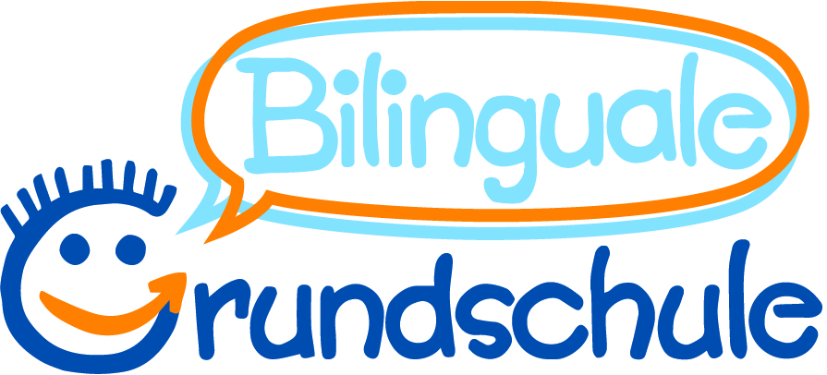

Questionnaire for enrollment at the Pestalozzi school
Dear Parents,

the school enrollment is a very important event to your child. As preparations for the new school year have already started, so it is important, that you answer the following questions in advance. The data are all treated confidentially.

Name oft he child: _______________________________________ Date of birth: ________________
Name of legal guardian: Mother: _______________________________________________________
Father: _______________________________________________________
phone number/mother: _______________________________________________________________
phone number/father: ________________________________________________________________
Child's address: ____________________________________________________________________

mailadress mother/father: _____________________________________________________________

Languages ​​in the family
Our child:
o grows up monolingually and o speaks German in the family
o speaks in the family ______________________________
o grows up bilingually: ____________________ and __________________________
o grows up multilingual: _______________________________________________________
Kindergarten / playschool / nursery school
Name of the Kindergarten: ________________________________________
Is your child taking a preparatory german course in this school year?
o no
o yes, at the Pestalozzi school with:
o Ms. Philipsen o Ms. Sauerborn o Ms. Chapman o Ms. Voigt
o yes, at another school: ___________________________________
I agree that primary school teachers exchange information about my child with the kindergarten teachers in order to make the transition as easy as possible for the child.
Class education
Do you have a wish about a classmate?
(The school tries, but cannot guarantee that the wishes will be taken into account!)

Name of the child: __________________________________________________________

Reason: o same Kindergarten o neighborhood
o same care in the afternoon o other ___________________________
Care in the afternoon
For the time after school you have to register your child independently in a care facility
(this is not done with this questionnaire!).
You can find the facilities on our homepage under "Care".

- Our child goes home after the morning class / regular lessons.
- We will register our child for the full day class.
- We will register our child for bilingual half-day class.
- We want to register our child for another afternoon care:
_____________________________________________________ (Name oft the organization)
- We are still thinking.

Religious education and ethics
The child is:
- evangelical o and takes part in evangelical lessons.
- catholic o and takes part in catholic lessons.
- islamic o and takes part in islamic lessons.
- without/another religion o and takes part in ethic lessons.
o but should take part in the:
o evangelical lessons
o catholic lessons
o islamic lessons.
Registration for the religious lesson is binding for one school year!

For the student file
In which city and in which country was the child born? _________________________________
What is the child's nationality? ___________________________________________
How long has the child been living in Germany? o birth o since ___. ___. _____ (dd/mm/yyyy)
Which language is spoken (often) in your family? ______________________________
Do the parents have a migration background? o yes, from ______________________ (country)
o no
If so, what status do you have?
o emigrant o Asylum seekers o war refugee o Foreigners
Remarks (what else is important to know)

date: ____________________ signature: ________________________________________

Please throw this questionnaire in the school mailbox until 25.01.2021.

